# PRACTICAL - 1

**AIM:** Identify the requirement and set objectives for a software project.

**Scenario:** Assume you are the project manager for a software development project. The project involves creating a new mobile application for a client. The client wants the application to enhance user engagement and include specific features.

**Task:**

1. Identify the requirements and list the key objectives for the PS APP and Inventory Management system.
2. Ensure that each objective follows the SMART criteria.
3. Create Epic, Stories and Tasks using Jira software.

**Solution :**

**Project Title :** PS APP

**Key Objective :**

* Develop user authentication and profile management system.
* Implement an inventory management system for in-app purchases and DLC tracking.
* Create a content browsing feature for games and media.
* Enhance user engagement with achievements, rewards, and notifications.
* Ensure cross-device synchronization of user data and content.

**SMART Criteria :**

* **S**pecific : Create an engaging, user-friendly mobile app with seamless onboarding, login, registration, password recovery, and a personalized home screen.
* **M**easurable : The app will achieve 90% user engagement by allowing users to register and log in easily, reducing drop-off during onboarding by 30%, and ensure password recovery is completed by at least 95% of users who request it.
* **A**chievable : Develop the app with the required features using an agile methodology, testing each feature in iterative sprints.
* **R**elevant : These features align with the client’s goal of increasing user engagement and retention through simplified access and personalized experience.
* **T**ime-bound : The application should be completed within 8 weeks, with specific milestones at the end of each sprint (2 weeks per sprint).

**Key Requirements :**

**Epic 1 : User Onboarding and Authentication**

**Story 1 :** Landing/Onboarding Page

* **Task 1 :** Design the “Landing/Onboarding” page with an engaging introduction to the app.
* **Task 2 :** Add a “Get Started” button that leads to the login/registration page.

**Story 2 :** User Login

* **Task 1 :** Create a login page with email and password fields.
* **Task 2 :** Implement token-based authentication (JWT).
* **Task 3 :** Add an option for users to log in via social media accounts (Google/Facebook).

**Story 3 :** User Registration

* **Task 1 :** Design a Registration form with fields for username, email and password.
* **Task 2 :** Implement server-side validation for registration inputs.
* **Task 3 :** Store user registration data securely in the database.

**Story 4 :** Forgot Password

* **Task 1 :** Design a “Forgot Password” page with an email input for password reset.
* **Task 2 :** Implement email-based password recovery.

**Epic 2 : Home Page and Content Display**

**Story 1 :** Home Page Layout

* **Task 1 :** Design the homepage with a carousel for featured games.
* **Task 2 :** Create a section with game cards to display popular games.
* **Task 3 :** Implement a search bar for users to search specific games.

**Story 2 :** Game Interaction

* **Task 1 :** Implement tap functionality on game cards to view game details.
* **Task 2 :** Integrate a rating system to allow users to rate games.

**Epic 3 : Shopping Cart and Favourite System**

**Story 1 :** Shopping Cart

* **Task 1 :** Design the shopping cart page with options to view added items.
* **Task 2 :** Implement functionality to add, remove and edit items in the cart.
* **Task 3 :** Integrate the checkout process for in-app purchases.

**Story 2 :** Favourite System

* **Task 1 :** Add functionality to allow users to mark games as favourites.
* **Task 2 :** Display a list of favourite games on the “Favourite” page.

**Epic 4 : Notification and User Profile**

**Story 1 :** Notification System

* **Task 1 :** Implement a notification system to notify users of new content and updates.
* **Task 2 :** Design a notification page to show all user alerts.

**Story 2 :** User Profile

* **Task 1 :** Create a profile page to display personal details such as username, email and preferences.
* **Task 2 :** Add functionality to update personal details and preferences.
* **Task 3 :** Integrate a profile picture upload option.
* **Task 4 :** Also add a tab for the order history.

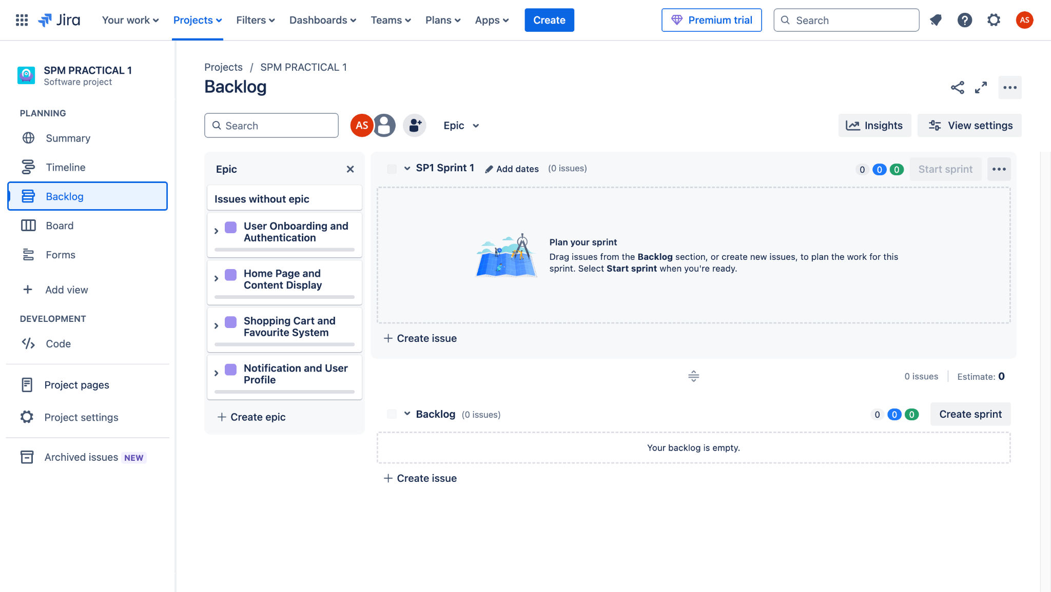

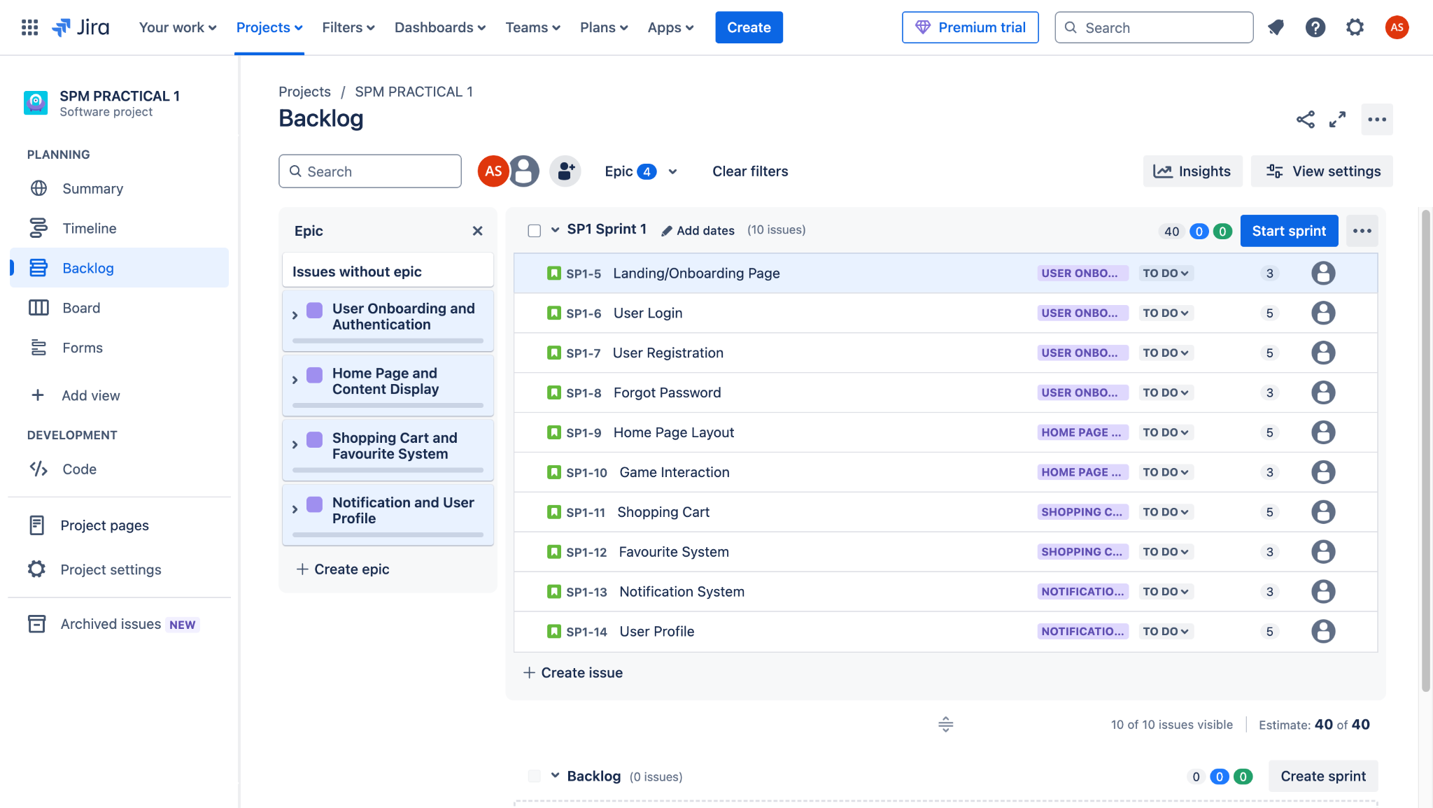

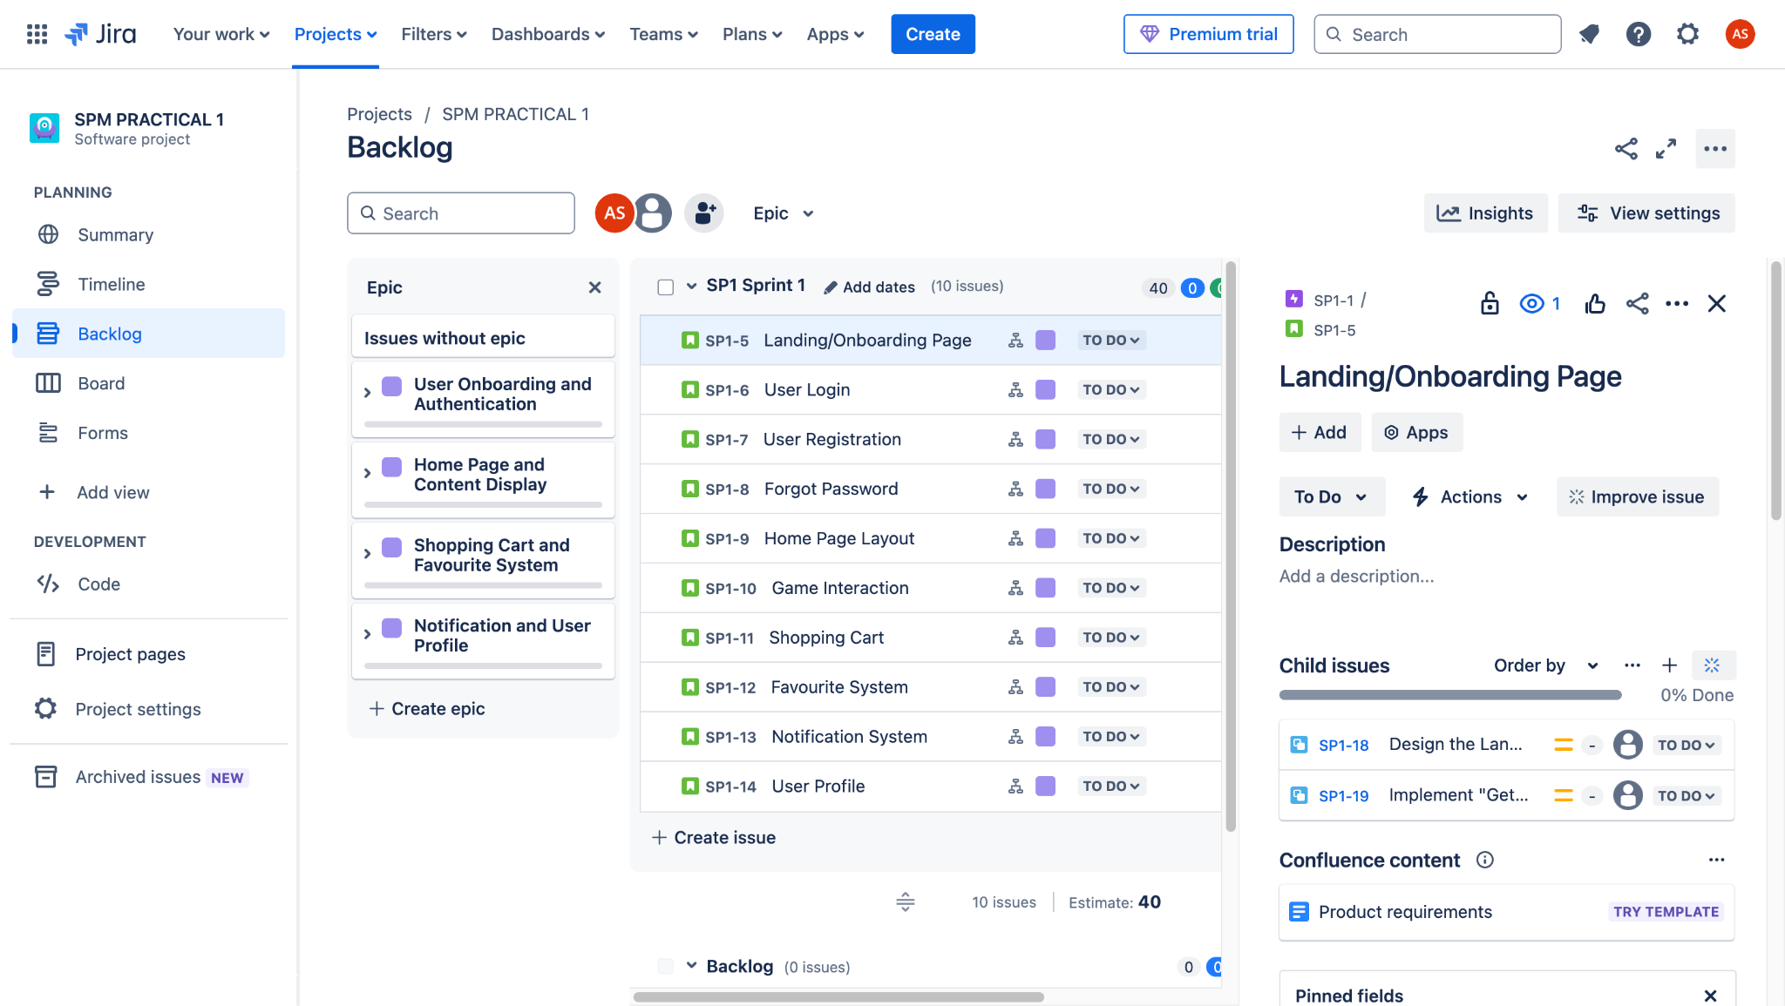

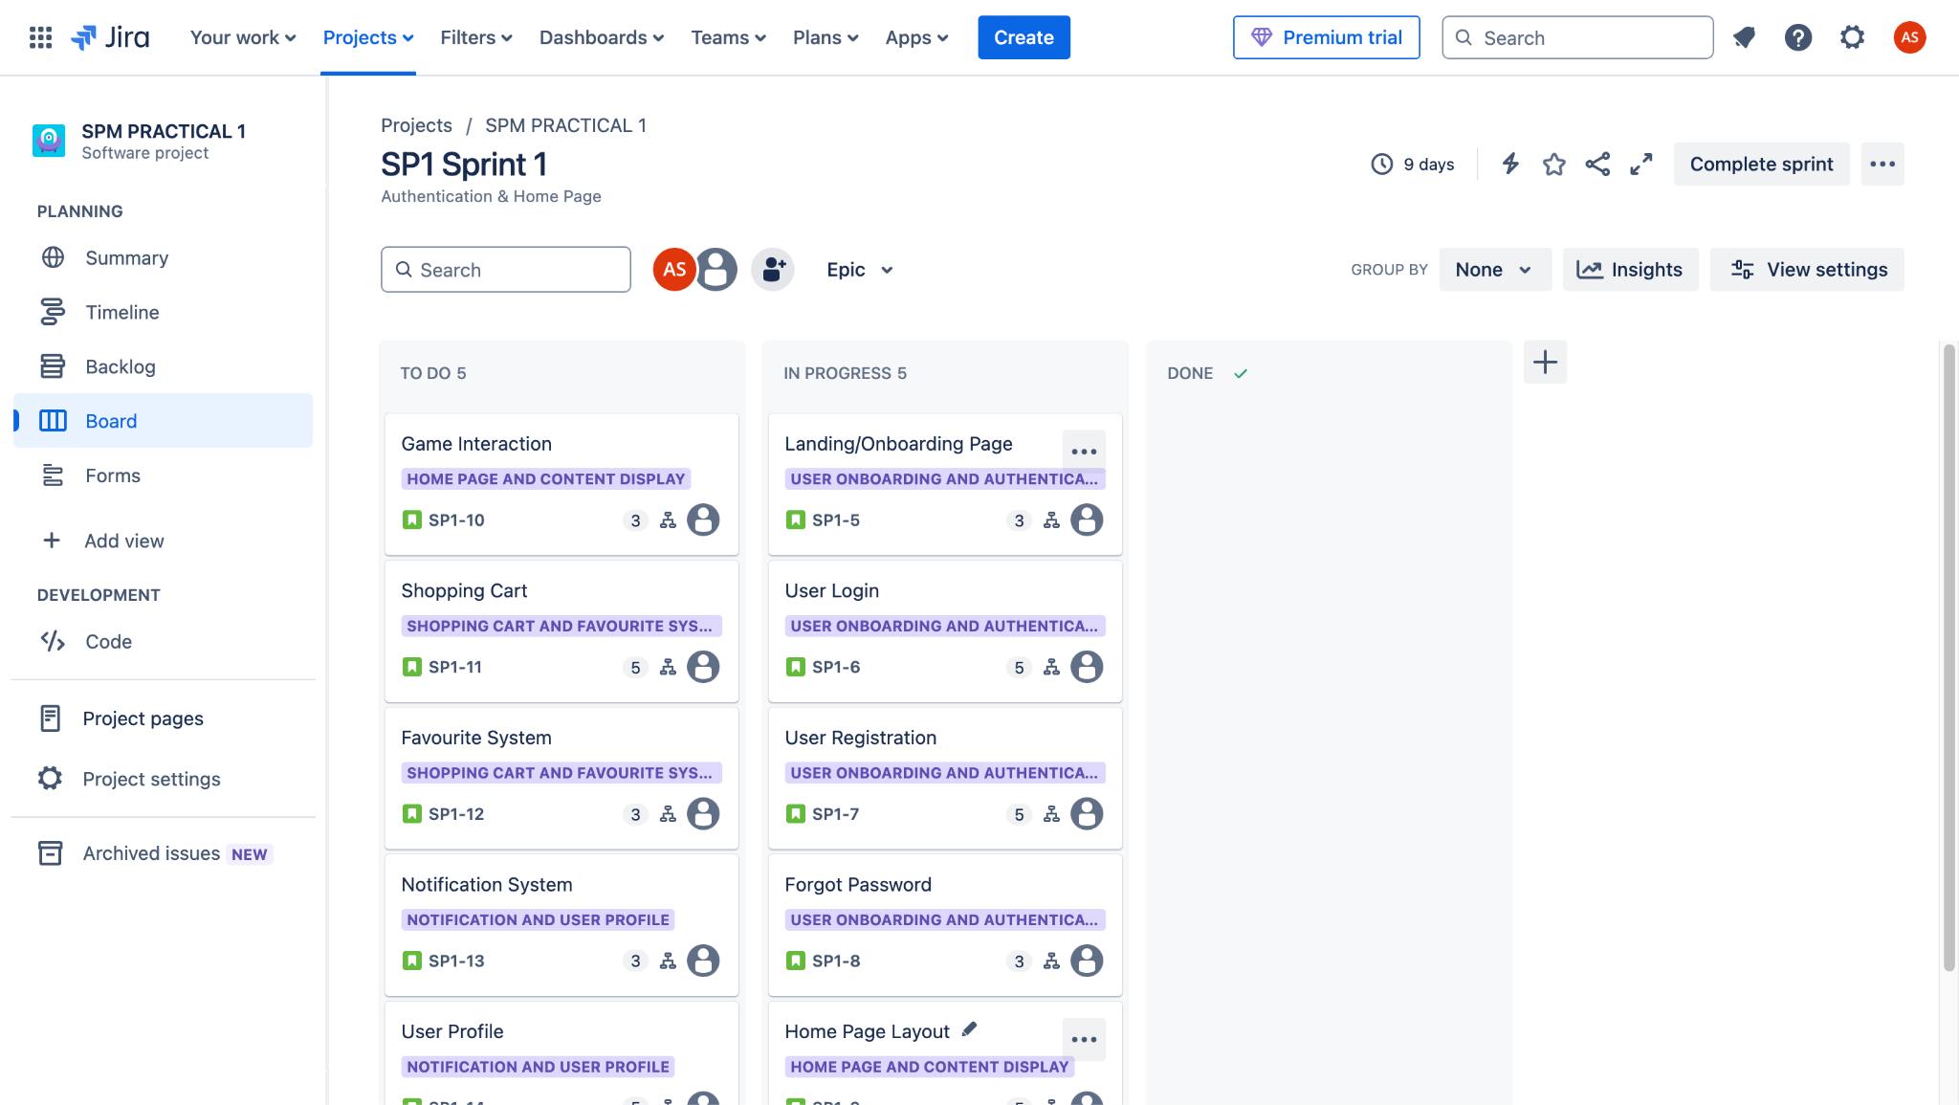

**Project Title :** Stock Inventory Management System

**Key Objective :**

* Develop a secure user authentication and role-based access system.
* Implement an efficient stock management system for tracking inventory levels and stock movements.
* Create a product catalog with categorization, search, and filtering options.
* Enable order management, including stock purchases, sales, and restocking.
* Implement a notification system for low stock alerts and order updates.

**SMART Criteria :**

* **S**pecific**:** Build an inventory management system with features for product tracking, stock monitoring, order processing, and real-time notifications.
* **M**easurable**:** Ensure 95% accuracy in stock tracking, reduce manual inventory errors by 40%, and improve order processing efficiency by 50%.
* **A**chievable**:** Develop the system in iterative sprints using agile methodology with regular testing.
* **R**elevant**:** The system addresses the need for streamlined inventory tracking and order management, improving business efficiency.
* **T**ime-bound**:** Complete the application within 8 weeks, with bi-weekly sprints focusing on key modules.

**Key Requirements :**

**Epic 1 : User Authentication and Role Management**

**Story 1 :** User Login & Role-Based Access

* **Task 1:** Implement a secure login system for admins, managers, and staff.
* **Task 2:** Restrict access based on user roles (e.g., only admins can add new products).

**Story 2 :**User Registration & Profile Management

* **Task 1:** Design a registration form for new users with role selection.
* **Task 2:** Implement profile management features for updating user details.

**Story 3 :** Password Recovery

* **Task 1 :** Implement a "Forgot Password" feature using email verification.\

**Epic 2 : Stock Management System**

**Story 1 :** Product Catalog

* **Task 1:** Develop a database schema for product details (name, SKU, price, quantity, supplier, etc.).
* **Task 2:** Create a product listing page with categorization and filtering options.

**Story 2 :** Stock Tracking & Updates

* **Task 1:** Implement real-time stock level tracking.
* **Task 2:** Add functionality to update stock when new items are received or sold.

**Epic 3 : Order Management**

**Story 1 :** Stock Purchase Orders

* **Task 1:** Create a module for adding new stock purchase entries.
* **Task 2:** Implement approval workflow for purchase orders.

**Story 2 :**  Sales Order Processing

* **Task 1:** Develop an interface to create and manage sales orders.
* **Task 2:** Integrate automatic stock deduction when an order is confirmed.

**Epic 4 : Notification & Reporting**

**Story 1 :** Low Stock Alerts

* **Task 1 :** Implement an automatic alert system for low stock levels.

**Story 2 :** Order & Inventory Reports

* **Task 1:** Generate daily, weekly, and monthly reports on stock levels and order history.

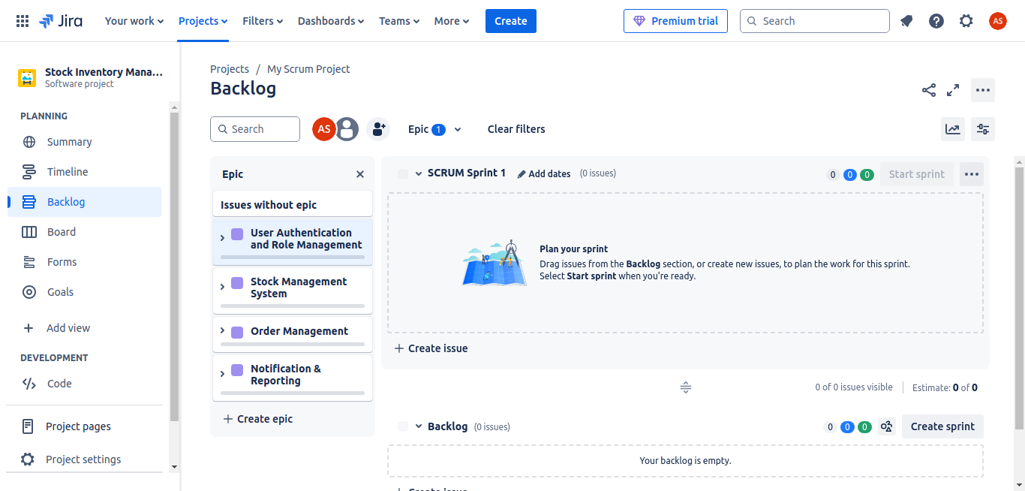

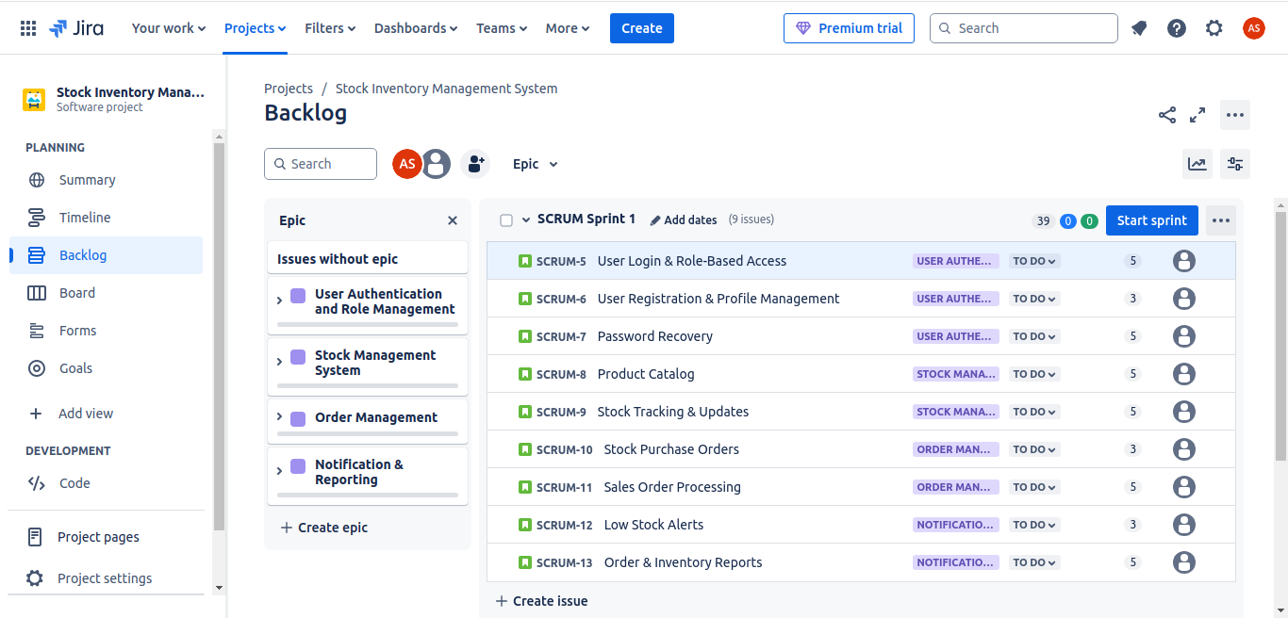

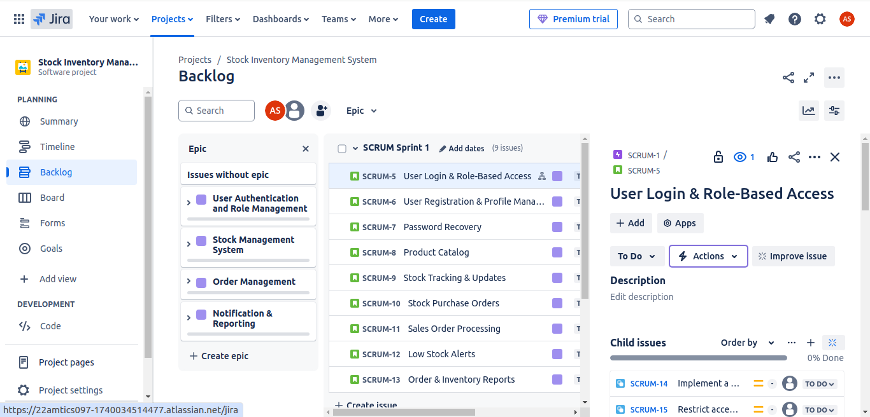

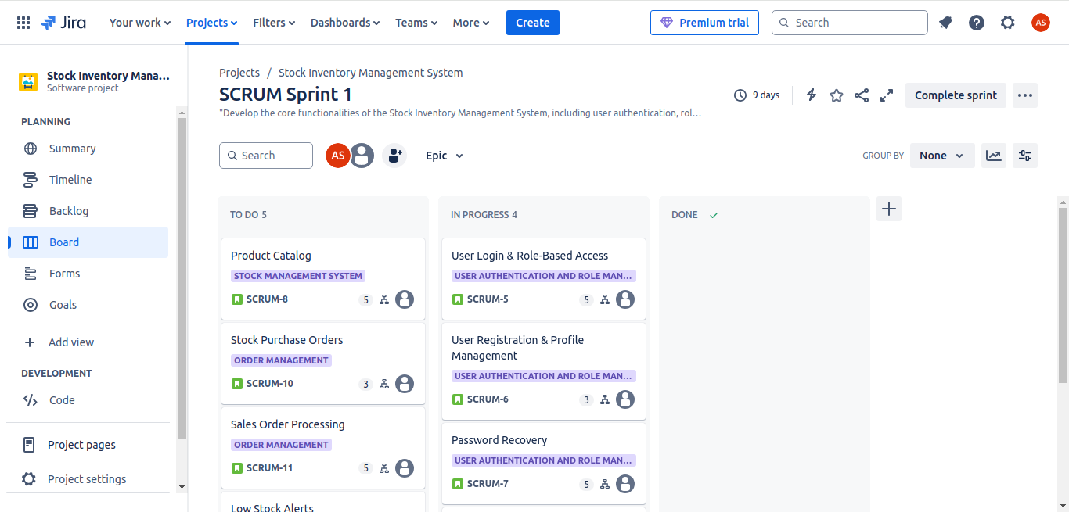

# PRACTICAL - 2

**AIM:** Categorization of software projects (select any two projects from annexure – I)

**Task:**

1. Study and Identify the requirements, modules and list the key objectives for the mobile application project
2. Study the different categories of software projects.
3. Categorize projects based on size, complexity, and criticality.
4. Justify your categorization decisions.

**Solution :**

**Team Details :**

| **Sr. No.** | **Name** | **Enrollment No.** |
| --- | --- | --- |
| **Team Leader** | **Gati Shah** | **202203103510261** |
| **Team Member 1** | **Fenil Shilodre** | **202203103510041** |
| **Team Member 2** | **Angat Shah** | **202203103510097** |
| **Team Member 3** | **Yash Patel** | **202203103510228** |
| **Team Member 4** | **Sarth Chaudhari** | **202303103510106** |

**Project Title : Airbnb System**

**Introduction :**

Airbnb is a digital marketplace that connects travelers with property owners who offer short-term accommodations. The platform allows users to browse, book, and manage stays, while hosts can list and monetize their properties. The system includes web and mobile applications, ensuring a seamless experience for users worldwide.

**Key Objective :**

* Provide a seamless booking experience for users
* Enable hosts to list and manage properties efficiently
* Ensure secure transactions and payments
* Maintain a user-friendly interface
* Support multiple languages and currencies

**Modules:**

* User Management – Registration, login, profile setup.
* Property Listings – Add, update, delete properties.
* Search & Booking – Filtering, availability checks, reservations.
* Payments & Transactions – Payment gateway integration.
* Reviews & Ratings – Feedback system.
* Messaging & Notifications – In-app communication, alerts.
* Admin Panel – Manage users, listings, and disputes.

#### **Requirements:**

* User authentication and profile management
* Property listing and management
* Booking and payment system
* Review and rating system
* Search and filter functionalities
* Messaging and notifications

### **Based on Size:**

* Large-scale system due to its extensive global user base.
* Requires a distributed cloud infrastructure to handle high traffic.
* Involves multiple integrations (payments, maps, messaging).
* Manages large volumes of data, including images, transactions, and user activity.

### **2) Study the Different Categories of Software Projects**

Software projects can be classified into:

* Application Software – User-centric, such as Airbnb, Uber.
* System Software – OS, drivers, middleware.
* Embedded Software – Used in IoT, robotics.
* Web-based Software – Websites, cloud platforms.
* Mobile Applications – Native or hybrid mobile apps.

**Airbnb falls under Application Software and Web-based Software.**

### **3) Categorization Based on Size, Complexity, and Criticality**

#### **Size: Large**

* Airbnb is a large-scale system with millions of users.
* Requires vast server infrastructure and cloud scalability.

#### **Complexity: High**

* Multiple integrations (payment systems, maps, messaging).
* Secure transactions and real-time data processing.
* Advanced search and recommendation algorithms.

#### **Criticality: Moderate to High**

* Financial transactions make security crucial.
* User data privacy and compliance (GDPR, PCI-DSS) are mandatory.
* Service downtime impacts business operations and user experience.

### **4) Justification for Categorization**

* Size: Large due to global reach and extensive features.
* Complexity: High because of real-time updates, dynamic pricing, and fraud prevention mechanisms.
* Criticality: Moderate to high since security and uptime are essential, but not life-critical (e.g., unlike healthcare or aviation systems).

**Project Title : Farfetch E-commerce System**

**Introduction :**

Farfetch is an online luxury fashion marketplace that connects customers with boutiques and brands around the world. The platform allows users to browse and purchase high-end clothing, shoes, accessories, and more. It provides a seamless shopping experience, including secure payments, order management, and global shipping options, catering to the needs of fashion-conscious consumers worldwide.

**Key Objective :**

* Provide an intuitive and user-friendly platform for luxury fashion shopping.
* Enable boutiques and brands to list and manage their product inventory.
* Ensure secure and reliable payment processing.
* Offer personalized recommendations based on customer preferences and browsing behavior.
* Provide global shipping and easy returns for international customers.

**Modules:**

* User Management – Account creation, login and profile management.
* Product Catalog – Displaying products, product descriptions and sorting.
* Shopping Cart & Checkout – Add products to the cart, handle order processing.
* Payment Gateway – Secure online payment processing with multiple payment methods.
* Order Management – Track orders, delivery status and manage returns.
* Inventory Management – Real-time stock updates, alerts for low stock.
* Personalized Recommendations – Suggest products based on browsing history and preferences.
* Admin Panel – Manage product listings, user accounts and order data.

#### **Requirements:**

* User authentication and profile management
* Product Listing and Inventory Management
* Shopping Cart & Checkout System
* Payment System Integration
* Order Tracking and Delivery Management

### **Based on Size:**

* Medium to Large-scale system due to its global reach and complex operations.
* Requires an extensive server infrastructure to handle large numbers of users and transactions.
* Involves multiple third-party integrations (payment gateways, delivery services).
* Handles a large variety of products, brands, and customer data.

### **2) Study the Different Categories of Software Projects**

Software projects can be classified into:

* Application Software – User-centric, such as Farfetch, Amazon.
* System Software – OS, drivers, middleware.
* Embedded Software – Used in IoT, robotics.
* Web-based Software – Websites, cloud platforms.
* Mobile Applications – Native or hybrid mobile apps.

**Farfetch falls under Application Software and Web-based Software.**

### **3) Categorization Based on Size, Complexity and Criticality**

#### **Size: Medium to Large**

* Farfetch is a large-scale system with a global user base.
* Requires robust server infrastructure and cloud scalability to handle high traffic.
* Manages extensive product catalogs, user data, and transactions across different regions.

#### **Complexity: Medium to High**

* Involves multiple integrations (payment systems, logistics, inventory management).
* Real-time inventory updates and personalized product recommendations.
* Requires secure transactions and global shipping management.

#### **Criticality: Moderate to High**

* Financial transactions and customer data security are essential.
* Compliance with international data protection regulations (e.g., GDPR).
* Downtime or service failures could lead to loss of sales and damage to customer trust.

### **4) Justification for Categorization**

* Size: Medium to Large due to its global reach, diverse product offerings, and large user base across multiple regions.
* Complexity: Medium to High because of the need for real-time inventory management, integration with third-party services, and the implementation of personalized recommendations and dynamic pricing.
* Criticality: High since financial transactions and customer data security are vital, and any downtime could lead to significant financial loss and impact customer trust.

# PRACTICAL - 3

**AIM:** Study cost-benefit evaluation Techniques and apply for project Selection

**Scenario:** Assume you are a project manager in a technology company, and your organization is considering two potential projects: **Airbnb System** and **Farfetch E-commerce System**. Both projects have different scopes, costs, and expected benefits.

**Task:**

1. Study cost-benefit evaluation Techniques
2. Conduct a cost-benefit analysis for both projects by using techniques such as Return on Investment (ROI) and Net Present Value (NPV) to evaluate and compare the projects.
3. Make a recommendation on which project should be selected based on the analysis.

**Solution :**

**Team Details :**

| **Sr. No.** | **Name** | **Enrollment No.** |
| --- | --- | --- |
| **Team Leader** | **Gati Shah** | **202203103510261** |
| **Team Member 1** | **Fenil Shilodre** | **202203103510041** |
| **Team Member 2** | **Angat Shah** | **202203103510097** |
| **Team Member 3** | **Yash Patel** | **202203103510228** |
| **Team Member 4** | **Sarth Chaudhari** | **202303103510106** |

**Cost-Benefit Evaluation Techniques :**

**Cost-Benefit Evaluation Techniques** are used to evaluate projects based on their expected benefits and associated costs. These techniques help in decision-making, especially when choosing between multiple potential projects. Below are the common techniques used in cost-benefit analysis:

**1.** **Net Profit**

Net Profit is the total benefit of a project after subtracting the total costs. This is used for a quick comparison of profitability but does not account for the timing of cash flows.

**2. Payback Period**

The Payback Period indicates the time taken for the initial investment to be recovered from the cash inflows. Shorter payback periods are generally more desirable.

**3. Return on Investment (ROI)**

ROI measures the profitability of a project relative to its cost. It is calculated as the ratio of the net profit to the total investment :

**ROI =**

A higher ROI indicates a more profitable project.

**4. Net Present Value (NPV)**

The NPV measures the profitability of a project by considering the time value of money. It discounts future cash flows to the present time and subtracts the initial investment. The formula is :

NPV =

Where :

*  = Cash flow in year 
*  = Discount rate
*  = Time period
* **I0** = Initial investment

The project with a higher NPV is considered more beneficial.

**5. Internal Rate of Return (IRR)**

IRR is the discount rate that makes the NPV of a project equal to zero. It represents the expected rate of return from the project. A higher IRR compared to the required rate of return makes the project attractive.

**IRR** =

**Cost-Benefit Analysis :**

***Project A : Airbnb System***

Initial Cost : $1,500,000

Expected Annual Benefits : Varying yearly cash flows

Project Lifespan : 5 years

**Table :**

| **Year** | **Cash Flow (Project A)** |
| --- | --- |
| 0 | -1,500,000 |
| 1 | 300,000 |
| 2 | 800,000 |
| 3 | 1,200,000 |
| 4 | 1,500,000 |
| 5 | 2,000,000 |
| **Net Profit** | **4,300,000** |

***Project B : Farfetch E-commerce System***

Initial Cost : $1,200,000

Expected Annual Benefits : Varying yearly cash flows

Project Lifespan : 5 years

**Table :**

| **Year** | **Cash Flow (Project A)** |
| --- | --- |
| 0 | -1,200,000 |
| 1 | 500,000 |
| 2 | 1,200,000 |
| 3 | 2,000,000 |
| 4 | 3,500,000 |
| 5 | 4,500,000 |
| **Net Profit** | **9,200,000** |

**ROI Calculation :**

***Project A*** *:* ***Airbnb System***

* **Net profit**

= $300,000 + $800,000 + $1,200,000 + $1,500,000 + $2,000,000 - $1,500,000

= $4,300,000

* **Total Investment** = $1,500,000 (Initial Investment)
* **Average Annual Profit** = = $860,000
* **ROI =**

**=**

**= 57.33%**

***Project B*** *:* ***Farfetch E-commerce System***

* **Net profit**

= $500,000 + $1,200,000 + $2,000,000 + $3,500,000 + $4,500,000 - $2,000,000

= $9,200,000

* **Total Investment** = $2,000,000 (Initial Investment)
* **Average Annual Profit** = = $1,840,000
* **ROI =**

**=**

**= 92%**

Recommendation : **Project B** offers a significantly higher return on investment, making it the more favorable option for maximizing profits.

**NPV Calculation:**

***Project A : Airbnb System***

| **Year** | **Cash Flow** | **Discount Factor (10%)** | **Discounted Cash Flow** |
| --- | --- | --- | --- |
| 0 | -1,500,000 | 1.0000 | -1,500,000 |
| 1 | 300,000 | 0.9091 | 272,727 |
| 2 | 800,000 | 0.8264 | 661,120 |
| 3 | 1,200,000 | 0.7513 | 901,560 |
| 4 | 1,500,000 | 0.6830 | 1,024,500 |
| 5 | 2,000,000 | 0.6209 | 1,241,800 |

* **NPV =** (-1,500,000 + 272,727 + 661,120 + 901,560 + 1,024,500 + 1,241,800)

= **$601,707**

***Project B : Farfetch E-commerce System***

| **Year** | **Cash Flow** | **Discount Factor (10%)** | **Discounted Cash Flow** |
| --- | --- | --- | --- |
| 0 | -2,000,000 | 1.0000 | -2,000,000 |
| 1 | 500,000 | 0.9091 | 454,545 |
| 2 | 1,200,000 | 0.8264 | 991,680 |
| 3 | 2,000,000 | 0.7513 | 1,502,600 |
| 4 | 3,500,000 | 0.6830 | 2,390,500 |
| 5 | 4,500,000 | 0.6209 | 2,795,050 |

* **NPV =** (-2,000,000 + 454,545 + 991,680 + 1,502,600 + 2,390,500 + 2,795,050)

= **$4,134,375**

Recommendation : Since **Project B** has a much higher NPV, it indicates that this project will generate more value in today’s terms. Therefore, **Project B** is the more favorable investment option.

**IRR Calculation :**

***Project A : Airbnb System***

| **Year** | **Cash Inflow** | **Discount Factor (10%)** | **Present Value (10%)** | **Discount Factor (12%)** | **Present Value (12%)** |
| --- | --- | --- | --- | --- | --- |
| 0 | -1,500,000 | 1.0000 | -1,500,000 | 1.0000 | -1,500,000 |
| 1 | 300,000 | 0.9091 | 272,727 | 0.8929 | 267,870 |
| 2 | 800,000 | 0.8264 | 661,120 | 0.7972 | 637,760 |
| 3 | 1,200,000 | 0.7513 | 901,560 | 0.7118 | 854,160 |
| 4 | 1,500,000 | 0.6830 | 1,024,500 | 0.6355 | 953,250 |
| 5 | 2,000,000 | 0.6209 | 1,241,800 | 0.5674 | 1,134,800 |
| NPV | | **2,601,707** | | **2,347,840** | |

* **IRR** =

= 10 +

= 10 +

= **20.50 %**

***Project B : Farfetch E-commerce System***

| **Year** | **Cash Inflow** | **Discount Factor (10%)** | **Present Value (10%)** | **Discount Factor (12%)** | **Present Value (12%)** |
| --- | --- | --- | --- | --- | --- |
| 0 | -2,000,000 | 1.0000 | -2,000,000 | 1.0000 | -2,000,000 |
| 1 | 500,000 | 0.9091 | 454,545 | 0.8929 | 446,450 |
| 2 | 1,200,000 | 0.8264 | 991,680 | 0.7972 | 956,640 |
| 3 | 2,000,000 | 0.7513 | 1,502,600 | 0.7118 | 1,423,600 |
| 4 | 3,500,000 | 0.6830 | 2,390,500 | 0.6355 | 2,224,250 |
| 5 | 4,500,000 | 0.6209 | 2,795,050 | 0.5674 | 2,535,300 |
| NPV | | **6,134,375** | | **5,586,240** | |

* **IRR** =

= 10 +

= 10 +

= **32.38 %**

Based on the **ROI** and **NPV** analysis, **Project B (Farfetch E-commerce System)** is the more profitable and valuable investment, with a significantly higher ROI of 92% and an NPV of $4,134,375. Therefore, **Project B** should be preferred over **Project A (Airbnb System)**, which has a lower ROI of 57.33% and an NPV of $601,707.